

YEAR: 8
SUBJECT: SCIENCE

TEST: Elements, Compounds & Mixtures
TIME: 50 mins
QUESTIONS: Part A: Multiple Choice Questions (12 marks)
Part B: Short Answer Questions (26 marks)
Part C: Extended Answer Question (4 marks)

TOTAL MARKS: 42 marks

DO NOT WRITE ON OR MARK THIS PAPER
Part A: Multiple Choice Questions (1mark each)
Answer this section on the separate multiple – choice answer sheet
- Describe the particles in a solid. The particles in a solid are
- strongly bonded to each other so the solid has a definite shape.
- strongly bonded to each other so the solid does not have a definite shape.
- weakly bonded to each other so the solid has a definite shape.
- weakly bonded to each other so the solid does not have a definite shape.

- Identify why gases are easily compressed.
- the particles can diffuse.
- there is pressure between particles squashing them together.
- there is great energy between the particles allowing them to change.
- there is a lot of space between the particles.

3. The state of matter with the strongest force of attraction between the particles is:
- solids.
- liquids.
- gases.
- solids and liquids.

4. Matter that is composed of only one type of atom is
- an element.
- a compound.
- a molecule.
- a mixture.

- Four different substances were transferred from a test tube to a beaker. The table below shows changes of shape or volume which occurred.
Substance | Did it change its shape when transferred? | Did it change its volume when transferred?
A | YES | YES
B | YES | NO
C | NO | YES
D | NO | NO

Which one of the substances do you think was solid?
- A
- B
- C
- D
6. Chemists use symbols to identify each element. Recall which feature is true of these
symbols. They:
- mostly contain one or two letters.
- always use the first letter of the element name.
- are arranged in the periodic table alphabetically.
- must use only capital letters.

7. Recall the scientific term used to describe the process of a gas changing to a liquid.
- evaporation.
- boiling.
- condensation.
- sublimation.

8. If pure baking soda is a compound, then it is certain that baking soda:
- contains some oxygen combined with other elements.
- contains more than one element chemically bond to each other.
- could be physically changed into elements and compounds.
- is a simple mixture of elements.

9. When a solid object is heated, its particles:
- vibrate less rapidly and cause it to contract.
- vibrate more rapidly and cause it to expand.
- attract each other more, causing contraction.
- shrink in size so the gaps between them increase.
10. The group that contains chemical elements only is:
- carbon, water, oxygen
- zinc, hydrogen, carbon
- water, iron, salt
- sugar, sulphur, salt

11. Tap water is best described as:
- an element.
- a compound.
- a mixture.
- an alloy.

12. Melting point is the temperature at which a
- liquid changes to a gas.
- solid changes to a gas.
- liquid changes to a solid.
- solid changes to a liquid.

YEAR: 8
SUBJECT: SCIENCE
Name__________________________________________________
Form ____________

TEST: Elements, Compounds & Mixtures
TIME: 50 mins
QUESTIONS: Part A: Multiple Choice Questions (12 marks)
Part B: Short Answer Questions (26 marks)
Part C: Extended Answer Question (4 marks)

TOTAL MARKS: 42 marks

Part A: Multiple Choice Answers (1mark each)
Put a cross (X) through the correct answer.

1 a b c d
2 a b c d
3 a b c d
4 a b c d
5 a b c d
6 a b c d
7 a b c d
8 a b c d
9 a b c d
10 a b c d
11 a b c d
12 a b c d

Part A: Part B: Part C:
Multiple Choice Short Answer Extended Answer Total

/12
/20

/26

/42

/4

Part B: Short Answer Questions
13. Label the following diagrams as representing a solid, liquid and gas. (3 marks)
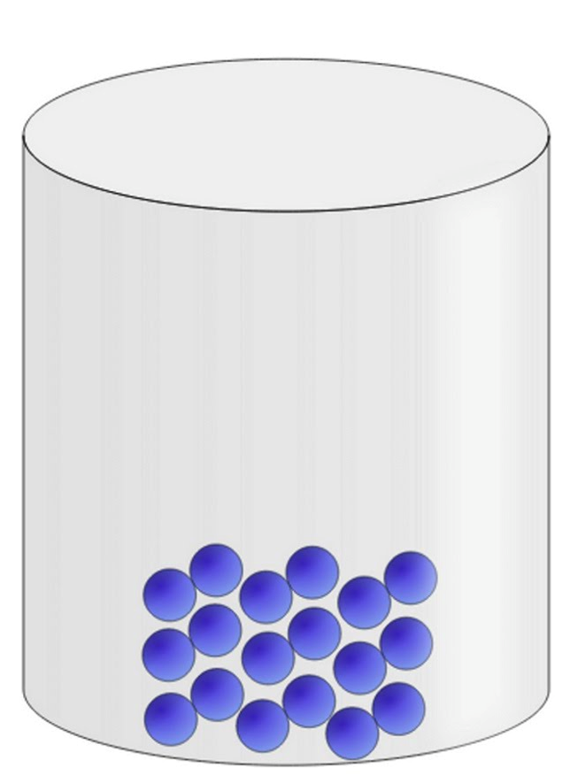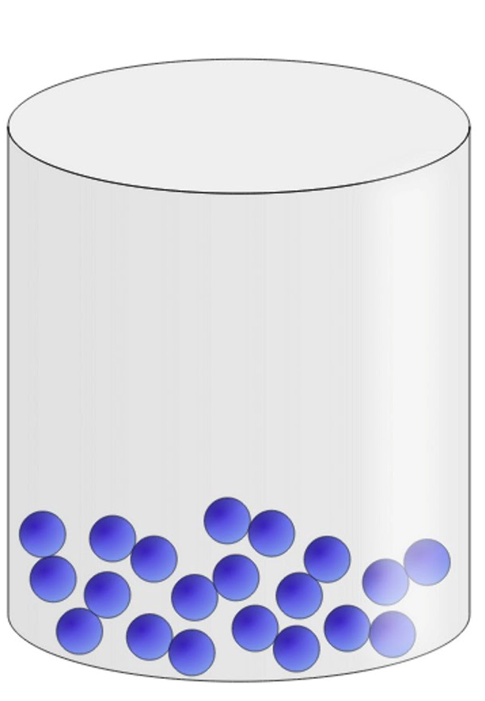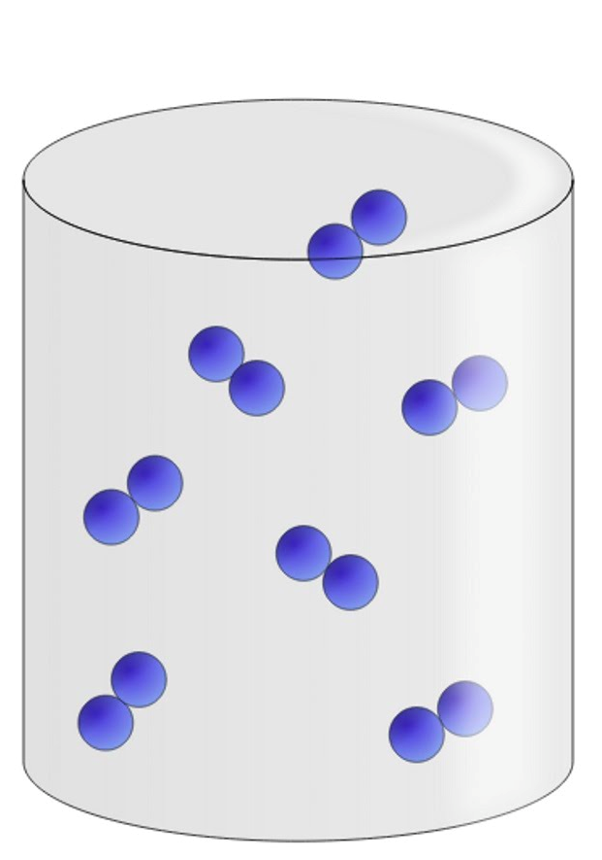
- ______________ 2. _______________ 3. ________________
Identify the following statements as describing a solid, liquid or gas.
a) Particles have very high energy and are free to move in all directions. _____________
b) Particles have low energy and are held in a fixed, rigid arrangement. _____________
c) Particles have medium energy and can slide past each other. _____________

14. Identify the ‘states of matter’ and the names of the processes occurring between each change of state. (4.5 marks)
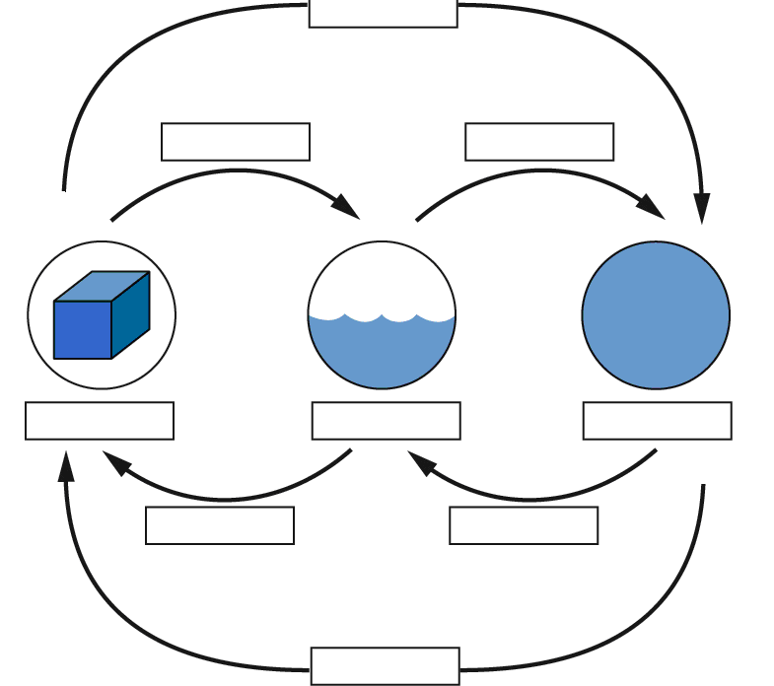

15. Identify the name or symbol of the elements given below. (3 marks)
a) H _____________ d) Carbon _______________
b) Mg _____________ e) Sodium _______________
c) O _____________ f) Potassium ______________

16. Define chemical property. Use an example of a chemical property of a state of matter to support your answer.
(2 marks)
______________________________________________________________________________________________________________________________________________________
17. Define the following properties: (2 marks)
Hardness
______________________________________________________________________________________________________________________________________________________
Viscosity
______________________________________________________________________________________________________________________________________________________

18. Explain why a cork will float in water, but a rock will not. (2 marks)

_________________________________________________________________________________________________________________________________________________________________________________________________________________________________
19. What is the difference between solidification and sublimation? (1 mark)
______________________________________________________________________________________________________________________________________________________

20. Complete the table below: (4.5 marks)
Example | State before the change took place | State after the change took place | Name for the change of state | Is heat energy gained or lost for the change of state to occur?
Mirror fogging up in the bathroom | Gas |  | Condensation | Lost
Spilt petrol drying up |  | Gas
An ice-cream block left in the sun | Solid |  | Melting
Making ice |  | Solid

21. Define the following: (2 marks)
Atom ______________________________________________________________________________________________________________________________________________________
Molecule
______________________________________________________________________________________________________________________________________________________
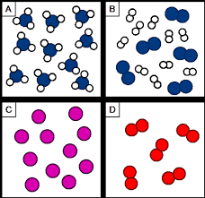
22. Look at the following diagram and label each one as an element, compound or a mixture. (2 marks)

a)____________________________
b)____________________________
c)____________________________
d)____________________________
Part C: Extended Answer Questions
23. If you spray air freshener on one side of the room, you can typically smell it in a very short space of time especially on a warm day.

Use your understanding of the link between the particle model and temperature changes to explain how the diffusion of air freshener is influenced by temperature. (4 marks)
______________________________________________________________________________________________________________________________________________________________________________________________________________________________________________________________________________________________________________________________________________________________________________________________________________________________________________________________________________________________________________________________________________________________________________________________________________________________________________________________________________________________________________________________________________________________________________

